Big O notation is used to describe the time or space complexity of algorithms.
It represents the upper bound or the worst-case of an algorithm’s time or space complexity.
It describes the order of growth of time or space in terms of input size of a function, not its exact value.
It can be used to compare the efficiency of different algorithms or data structures.

Linear Search

Best case: O (1)
If the element we are searching is the first element.
Average case: O (n)
Element is found after checking some elements.
Worst case: O (n)
If the element we are searching is not present or the last element.

Binary Search

Best case: O (1)
If the element we are searching is the middle element.
Average case: O (log n)
Element is found after checking some elements.
Worst case: O (log n)
If the element we are searching is not present or the last element.

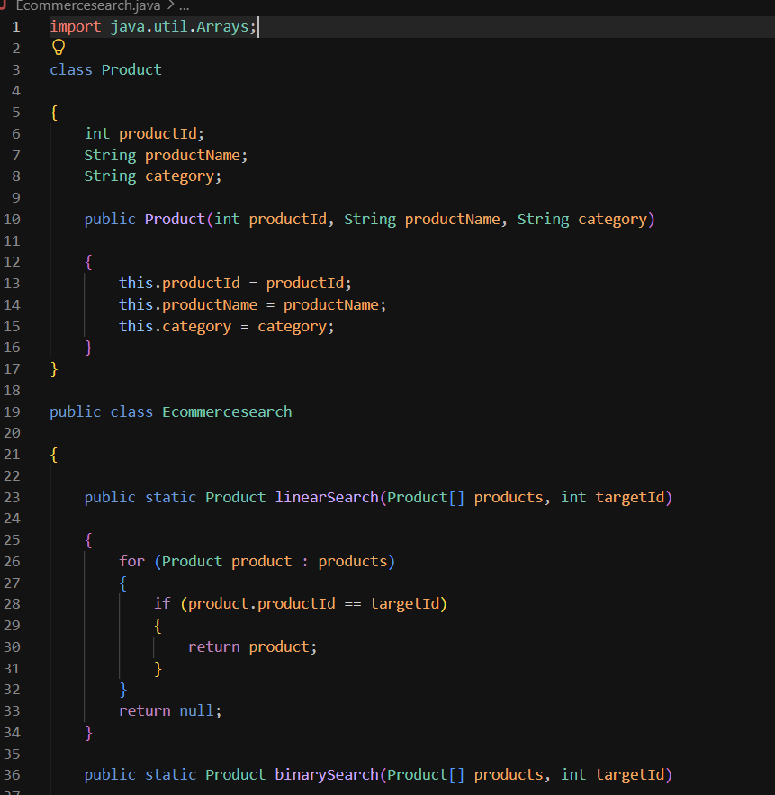

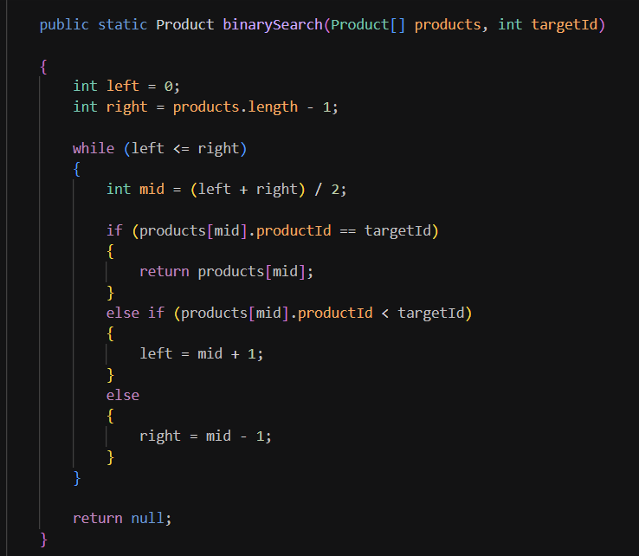
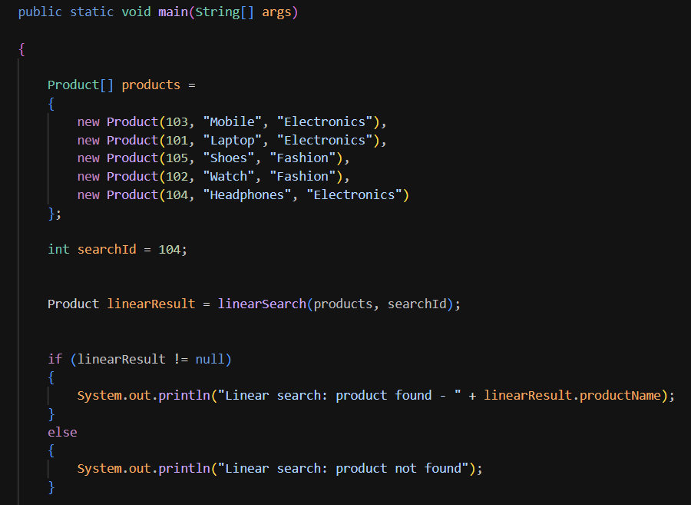

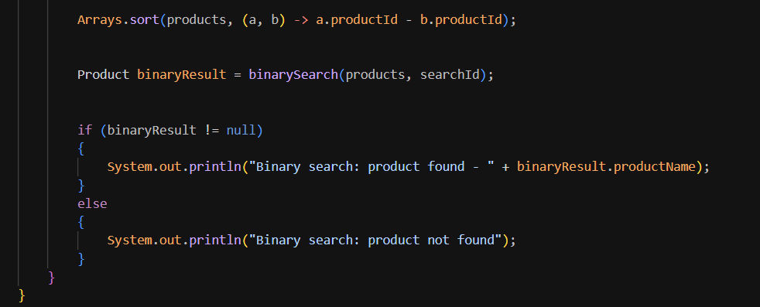

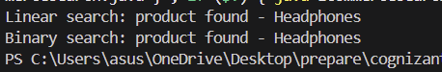

For an e-commerce platform, Binary search is more suitable because it provides faster search performance with a time complexity of O (log n). Since e-commerce platforms manage a large number of products, Binary search can significantly reduce search time compared to Linear search.

